West Racine Business Assistance Program: Business Recovery Grants

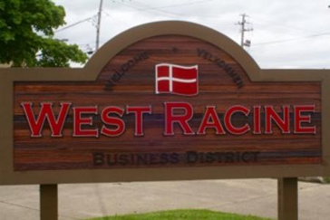

In partnership with Legacy Redevelopment Corporation (LRC), the City of Racine is proud to announce the West Racine Business Assistance Program, which offers grants of up to $10,000 for eligible businesses to cover anticipated expenses such as payroll, inventory, rent/mortgage, and other eligible expenses.

* *Eligible businesses must have an active physical location with an address along Washington Avenue from West Boulevard to the East and the City boundary to the West*
* *Applicants must have been in operation for at least one year prior to submission of the application*
* *Other restrictions apply, please contact LRC or the Department of City Development for details*

Applications will be received on a rolling basis, and awards will be funded on a first-come first-served basis

For more information and to receive an application, please contact Terese Caro at [tcaro@lrcmke.com](mailto:tcaro@lrcmke.com) or (414) 343-3091

Or call the City of Racine Department of City Development at (262) 636-9151 8am-5pm M-F if you have any questions

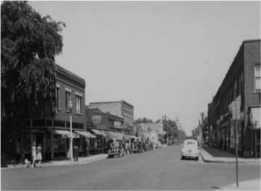

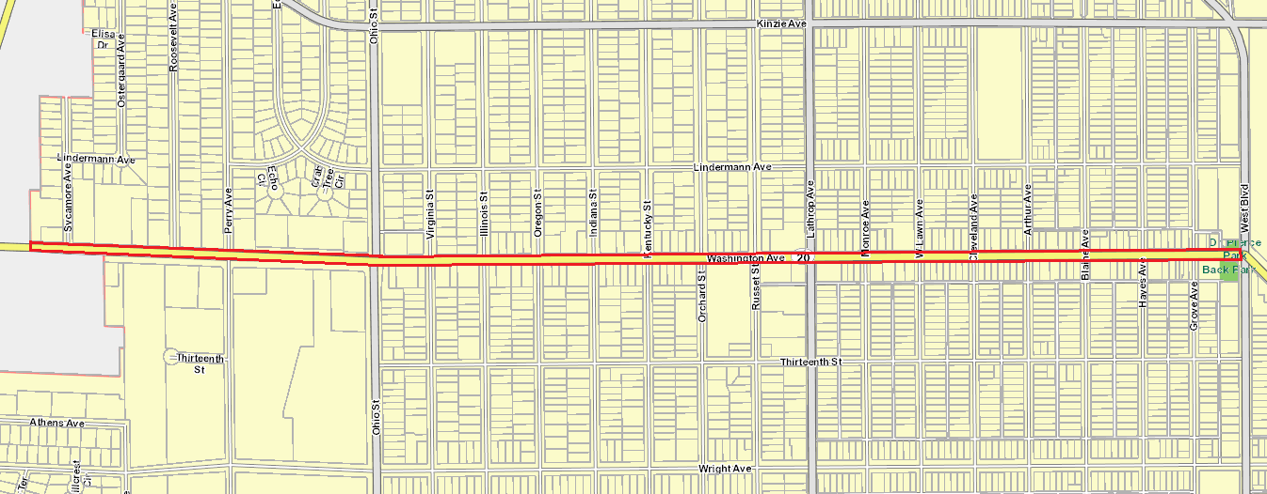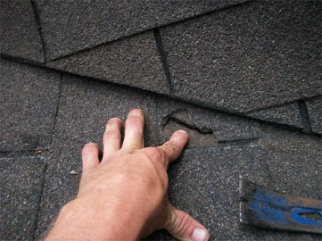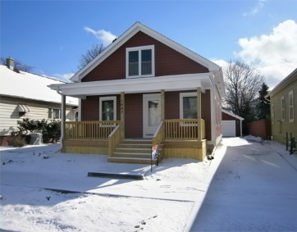

Alderperson Melissa Kaprelian